KASHMIR MEDICAL RELIEF TRUST (KMRT 1984-2015)
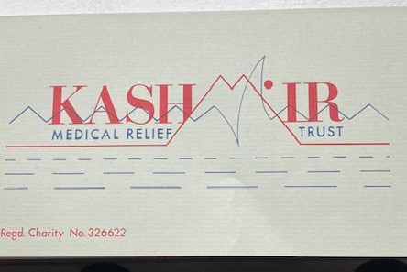
1984: Kashmir Medical Relief Trust was formed as a Charity and registered with the Charity Commission. Registration No: 326622
The following were the first Trustees who had the vision to set up a registered Charity to promote relief of sickness and disability in the State of Jammu & Kashmir.
Name | Location | Name | Location
Dr R A Akhtar | Sunderland | Dr Abdul Mahroo | Sunderland
Dr Nisar Bakhshi | Sheffield | Dr H Quereshi | Rotherham
Dr Mohan Lal BHan | Hinkley | Dr Aslam Rafiqui | Studley
Dr G J Drabu | Altrincham | Dr Muzafar Jeelani | Abergavenny
Mr Khurshid Drabu | Otterborne

Committee: Four ex-officio members, Chair, Vice Chair, Secretary and Treasurer and 6 elected members. Membership fee charged.
Aims: To promote relief of sickness and disability, by making provisions of expendable and non-expendable items of medical, surgical diagnostic and laboratory equipment and by providing facilities for higher training experience in various medical and paramedical fields. To collect and raise donations and accept donations The Trust deed for the relief of sickness in the State of Jammu and Kashmir. The Trust Deed was made on the 1st of June 1984. Fund for the relief of sickness in the State of Jammu and Kashmir.
The Kashmir Medical Relief Trust was registered as Charity under the Charity Commission on 6th July 1984, Charity No 326622
The Charity ceased operations on 31st March 2015. The Bank account was closed on 12th March 2015 Lloyds Bank account no 0314533; Sort code 30:98:34 Signatories Dr G J Drabu; Dr R A Sheikh; Dr A R Mahroo The Trustees at this time were Dr Ghulam Jeelani Drabu; Dr A R Sheikh; Dr N A Shameem; Dr N A Kuchai; Dr A R Mahroo. The independent examiners: Robert Miller& Co, Kings Hall, Imperial Buildings, Houghton le Spring, Tyne and Wear DH4 4DJ.
Summary letter sent to the Charity Commission “The Kashmir Medical relief Trust (KMRT) was formed in 1984 by some members of the Kashmir Medical Association of Great Britain. Over the period of years, the Association became non-functional and the Trust lost its main supporting body. The Trustees too with progression of age, retirement, health issues and moving away could not possibly provide the support as needed to run the Trust, with a very restrictive Trust deed no new Trustees could be appointed. Faced with these circumstances the Trustees decided to close the Trust in their meeting of 18th May 2014. While in the closing process a severe flood hit the Kashmir State. Considering the need of medical relief required the closure was temporarily delayed and effort diverted to collect funds for medical relief following the collection the funds were donated to the Indian Government recognised charities in Kashmir. The Trust was closed on September 2015. The Charity Commission is hereby requested to remove the Trust from its list. “
Dr G J Drabu -Chairman Dr Rashid Sheikh-Treasurer 22nd Nov 2015. Bank account closed 12 March 2015
The final amount raised by KMRT in 2015 was £73,829. Donations received in 2015 were £43,465 with Gift Aid refund of £8586.
https://register-of-charities.charitycommission.gov.uk/charity-search/-/charity-details/326622/full-print
Achievements of KMRT KMRT A Synopsis
1984: Kashmir Medical Relief Trust (KMRT) established by the Kashmiri Association of Great Britain. The aim was to promote relief of sickness, disability and provide facilities for higher training and experience in medical and paramedical fields in the State of Jammu and Kashmir, The Charity was registered under the laws of England and Wales.
KMRT engaged in partnership with local voluntary and charitable organisations on the State to achieve its aims,
- 89/90s Medical and Living support to residents of Sopore following disturbances
- 1997: KMRT involved with very first voluntary Blood transfusion service – (Husaini Blood Bank) Also involve vaccination of children in remote areas. Ambulance Transport facilities to Husaini Blood Bank and HBB also vaccinate children in remote
- 1997: Ambulance for sick patients, low income families
- 1997: Specialist surgical equipment for Bone and joint Hospital for spinal injury cases – Dr G Mir
- 2000: KMRT donated funds to improve living conditions of Leper Hospital in Srinagar.
- 2001 J & K Welfare Society
- 2005:Rs100,000 Earthquake donated to medical relief work on both sides of LOC. Help Poor Voluntary Trust
- 2007: Consignment of 750Kgs of medical equipment to State Hospital in Srinagar and Sopore. Lead Dr Mehroo
- 2010: KMRT sponsored the full costs of Advanced nursing course for 14 Kashmiri nurses in Riyadh in Association with Dr Faroque Khan
- 2013/4: KMRT Donated an ambulance for patient transportation with special provision for patients with limited means Help Poor Voluntary Organisation and SMH Hospital Rs6.5Lacs
- 2014 Fundraising for 2014 floods over £73,000 raised and sent to Kashmir Chinar and HELP.
- 2015 Charity Closed
2014 Flood relief Money that was raised for the relief of flood victims was deposited into the KMRT accounts was sent to Chinar Kashmir and HELP Foundation for medical and health related purposes. Both Chinar and HELP are registered charities to receive money from international sources. KMRT was registered on Total Giving on 30th September 2014 and closed on 16th Oct 2016. Charity Commission informed formally on 9th December 2015
Donations and Accounts over the Years
Year end | In Bank | Donations/income | Expenditure | Commentary
31st March 2015 | £73829 | £43465  £8586 | £300  £111
31st March 2014 | £21725 | £51 | £51
31st March 2013 |  | Rs6 Lacs |  | Help the Poor Voluntary Society
The money was used to get a ventilator cost Rs6.5 lacs c/o Dr Nigam of SMHS Hospital
31st March 2012 | £21,746 |  | £23
31st March 2011 | £28436 |  | £6,690
31st March 2009 | £28,435
31st March 2008 | £28,383
31st March 2007
31st March 2006 |  | £27,758  £401 | £10,000 | Rs8 lacs for Help the Poor Voluntary organisation for earthquake relief
31st March 2005 | £11000 |  | Nil
31st March 2004 |  | £280.7 | Nil
31st March 2003 |  | £135.26 | £5000  £25.00
31st March 2002 |  | £2000 from Muslim Aid 11th Nov 2001  £2898 members donation | Nil | Money from Muslim Aid used to Help the Poor Voluntary Trust  Rs1.3 lacs for repairs of Leprosy Colony (25/07/01)
31st March 2001 | £27,071.14 | £5,874.48 | £20,000 | Rs10,000 paid to J & K Yateem Trust  Rs5000 J & K Childrens Welfare Society
31st March 2000 | £21,096.66 | £5191.56 + interest £782.92 | £10,000 to Immam Hussain Hospital
1999* |  |  |  | Letter from Dr Drabu to membership outlining achievements to date .See below
1997 | - 1997: Ambulance Transport facilities to Hussaini Blood Bank = HBB also vaccinate children in remote areas  - Medical and Living support to resident of Sopore following disturbances in 89/90s  - 1977: Specialist surgical equipment for Bone and joint Hospital for spinal injury cases – Dr G Mir  - An ambulance for Hussaini Blood Bank to transport sick and injured
1980s |  |  |  | Transport facilities to Husaini Blood Bank to improve Blood Transfusion services. Hep B vaccination in remote villages
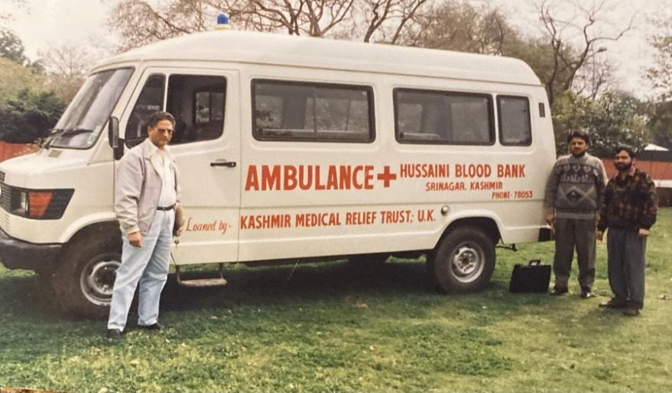 Ambulance donated by KMRT 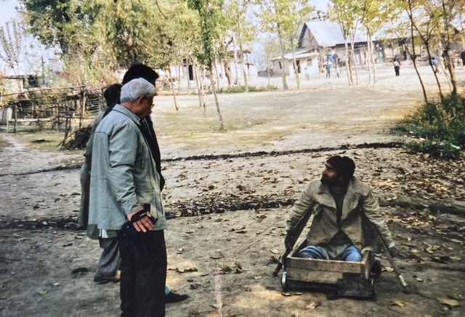Leper Colony Visit
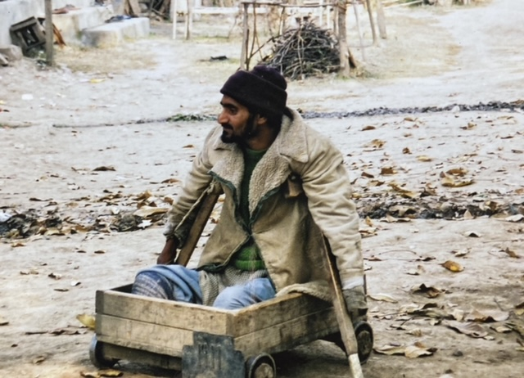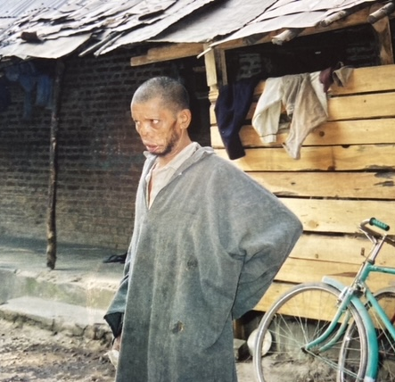 Visit to the Leper Colony

